**Observation**

Inspection was undertaken at the subject property in the presence of the Insured to which the following was noted:

## Swimming Pool Structure

1. The pool construction consists of metal sheets, carcass and supporting uprights which in our opinion, is typical of a pre-fabricated “above ground” swimming pool system.
2. At the time of our inspection, we noted a layer of bedding sand on the base of the subject pool. **Image 2**
3. Furthermore, we noted the pool has been partially constructed in an “in ground” application. **Image 3**
4. The subject pool protrudes approximately 0.4m above the ground level and it is approximately 1.3 m from the top of the pool rim to the top of the fill sand. **Image 4**
5. Given the above details, we confirm the subject swimming pool has been buried partially within ground retaining a minimum of 0.9m backfill.
6. As such, the embedment of the pool structure into the ground has resulted in “in-ground” application of the subject pool system contrary to the “above-ground” intended design and function.

## Draining of Swimming Pool

1. From the Insured’s provided advice, for general maintenance of the pool, they were intending to replace the liner of the subject pool as it was last changed six (6) years ago under a previous insurance claim.
2. Further to the above, the Insured advised that they had engaged a contractor to replace the lining however the contractor advised that that in order to proceed with removal and replacement of the liner, the pool was required to be emptied.
3. At the time of our inspection, we noted a pump set up on the base of the pool in which the Insured advised it has been used to drain the water from the subject pool approximately four (4) weeks ago. **Image 5**
4. In addition to the above, at the time of our inspection, we did not note any evidence of the addition of support props to resist the earth pressure during the water removal. **Image 6**
5. In order to obtain details of the condition of the pool prior to the wall collapse, we conducted a detailed review of satellite imagery of the subject property.
6. From our review of the satellite imagery, provided in ***Figures 2 - 7*** below, in our opinion, the pool was emptied sometime between November 2019 and March 2020.
7. Furthermore, in our opinion the pool was in poor condition and appeared to be unused for a significant period of time dating back to 2018 relative to colour of water.
8. Given the above, in our opinion due to the state of the pool in the years leading up to the wall buckling, the lining would have been extremely deteriorated and the environmental conditions of the pool water would have exponentially reduced the linings serviceable life.

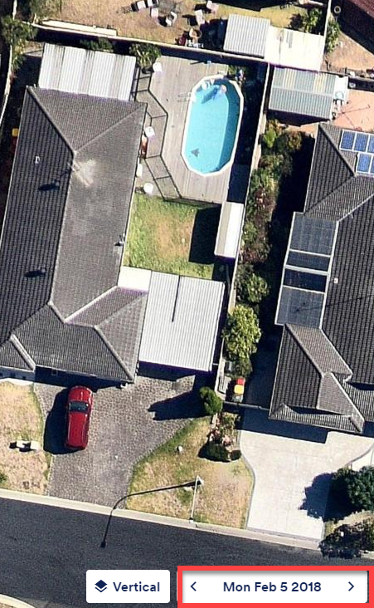

***Figure 2 – 5 February 2018 – Pool Filled with Water and Appears to be in Working Order***

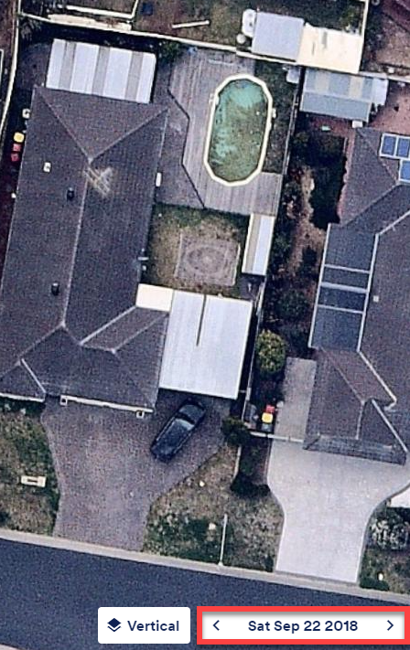

***Figure 3 – 22 September 2018 – Pool Filled with Water and Slightly Discoloured***

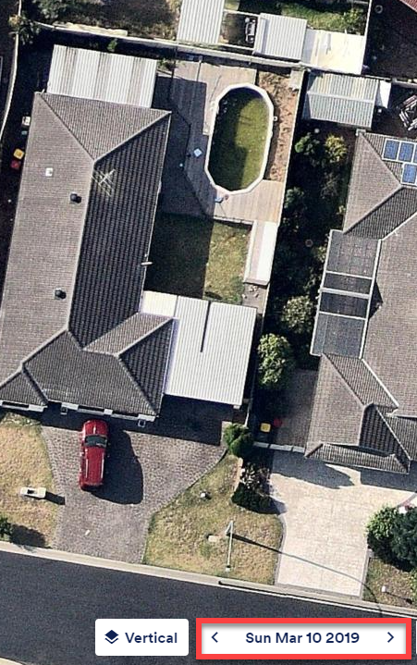

***Figure 4 – 10 March 2019 – Pool Filled with Water and Significantly Discoloured and Unused***

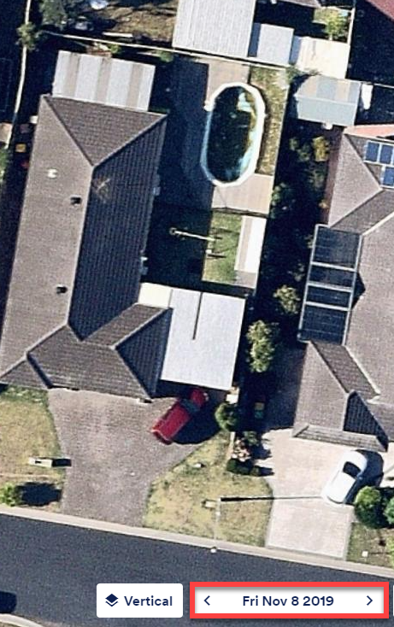

***Figure 5 – 8 November 2019 – Pool Filled with Water and Significantly Discoloured and Unused***

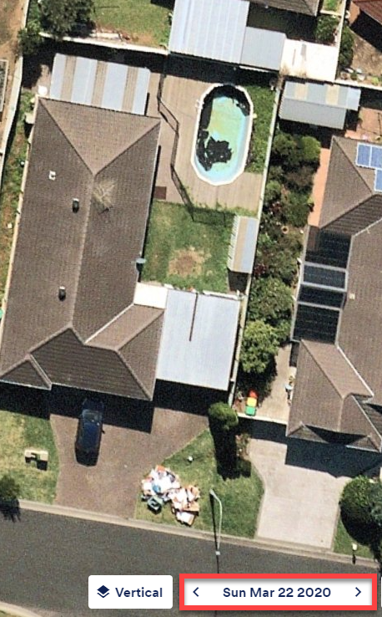

***Figure 6 – 22 March 2020 – Pool has been Emptied***

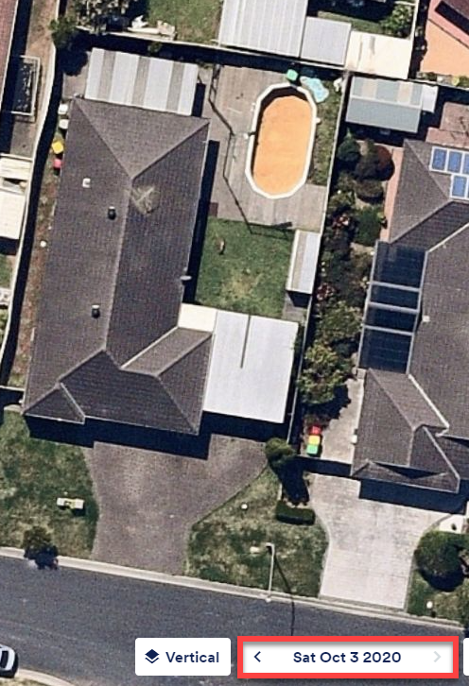

***Figure 7 – 3 October 2020 – Latest Imagery showing current state of Pool with Liner removed exposing Bedding Sand***

## Cause of Swimming Pool Wall Failure

1. In general, in-ground pools and in particular walls are subjected to two (2) loading cases namely lateral earth pressure and hydrostatic pressure acting from the backfill side.
2. In saying this, in contrast to “in-ground” pool systems, “above-ground” pool systems are not generally designed to withstand soil and hydrostatic pressures from the exterior of the pool and have been designed for containment of **pool water pressure only**.
3. In this case, the exerted earth and hydrostatic pressure onto the pool carcass associated with its construction in an “in-ground” system capacity is beyond the design function and intent of an “above ground” pool structure and its carcass.
4. In illustrating the mechanism of failure, we have provided a schematic diagram of the earth pressure and hydrostatic pressures acting on the external face of the pool structure in ***Figure 8.***

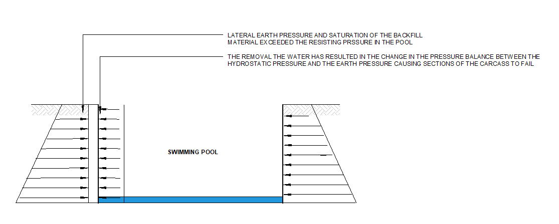

**Figure 8 - Schematic Diagram of Resultant Internal & External Pressures Acting on the Pool Structure and Carcass Resulting in the Buckling and Damage as Observed.**

1. On the above basis, the imbalance of the pressure between the earth pressure and the hydrostatic pressure from the due to the removal of the water in the pool has ultimately exceeded equilibrium within the pool structure’s stability causing failure and buckling about section of the carcass.
2. The loss of equilibrium between the resisting internal pressure and the applied external pressure has caused imbalance and ultimately the loss of the pool structural integrity.
3. Furthermore, re refer to a typical structural design used commonly by the industry for the construction of the in-ground pool using the above ground system which is prepared by Rickard Engineering Reference number 10041, dated 6 October 2017.
4. A copy of this structural drawing has been provided as ***Appendix A***.
5. Considering the above, from review of the Rickard Engineering drawings, we provide the following comments relative to critical construction requirements:
   1. Provided design drawing clearly indicated under **Notes 4 and 5** that the pool is to be filled and in case of pool being empty, laterally is to be propped.  
        
      The aforementioned Notes are consistent with requirements to resist the hydrostatic pressure component of the loads as explained above and are specified to ensure the imbalance between the external and internal pressures does not occur.
   2. With respect to the lateral earth pressure components of the loads, within the design drawing it is specified that the backfill of minimum 600mm wide behind the pool for clayey sites are required.  
        
      Backfill material is also specified to be mix of cement and sand with 1:8 mix ratio is to be used.  
        
      Use of cement will create a solid backfill once is installed and cement is cured bonding the sand together to ensure the backfill acts as a solid mass.  
        
      Such solid mass acts as a gravity system retaining wall which resists the lateral earth pressure by means of dead-weight and its specified footprint.
   3. In addition to above, a subsoil drainage system is also been specified; however, considering the above, such drainage is to mitigate durability of the steel uprights and to provide redundancy in design by reducing the long-term hydrostatic pressure.
6. Notwithstanding the above, from our site inspection, we noted that the backfill is general cohesive soil rather than the specified cement-sand mix which is not consistent with the typical Rickard Engineering design.
7. As such, the lateral earth pressure is only resisted by the steel uprights and their footing to which as indicated above is not structurally adequate.
8. To this end, in our opinion, the observed damage is unrelated to an insurable event and the failure is a direct result of incorrect measures undertaken during the pool draining and inadequacy of the original pool construction.

**Discussion**

NA

**Conclusion**

## Swimming Pool Structure

The subject pool protrudes approximately 0.4m above the ground level and it is approximately 1.3 m from the top of the pool rim to the top of the fill sand.

Given the above details, we confirm the subject swimming pool has been buried a minimum of 0.9m below the ground surface.

As such, the embedment of the pool structure into the ground has resulted in “in-ground” application of the subject pool system contrary to the “above-ground” intended design and function.

## Draining of Swimming Pool

From review of satellite imagery provided in the figures below, in our opinion, the pool was emptied sometime between November 2019 and March 2020.

Furthermore, in our opinion the pool was in poor condition and appeared to be unused for a significant period of time dating back to 2018.

Due to the structural characteristics of an above ground swimming pool and with reference to the typical structural design by Rickard Engineering, we confirm that the subject pool had been drained incorrectly and was left in a compromised state for an extended period of time.

## Cause of Swimming Pool Failure

To this end, in our opinion, the observed damage is unrelated to an insurable event and the failure is a direct result of the following measures:

* Incorrect measures undertaken during the pool draining relateive to absence of propping the walls;
* Leaving the subject pool unsupported in a compromised state;
* Inadequate maintenance practice in prior years; and
* Inadequacy of the original pool construction.